Logistic Loss & Cost Function
Extended lab from Coursera ML C1_W3 Labs 04–05 · short repo name: Logistic_Loss_Cost

Problem Statement
Linear regression trains on squared error, a smooth soup-bowl. Logistic regression outputs a sigmoid probability f ∈ (0,1) against a 0/1 label. Squaring (f − y) after a sigmoid is no longer a bowl: plateaus and ripples appear, so gradient descent is an unreliable trainer. We need a loss that is ~0 when the probability matches the label and grows without bound when the model is confident and wrong — then average that loss into a cost J(w,b) we can compare across candidate parameters.

Solution Strategy
- Show why squared error + sigmoid fails (1-D tumor-size toy set + (w,b) heatmap).
- Implement per-example logistic loss in piecewise and compact forms; clip f to avoid log(0).
- Average losses into J — loop form (original lab) and a vectorized alternate.
- Reproduce Lab05: J(w=(1,1), b=−3) ≈ 0.367 < J(b=−4) ≈ 0.504, matching the geometry.
- Monte-Carlo: vary m and label-flip rate; rewrite the same numbers for analyst / executive / non-specialist.

Solution
Compact loss L = −[y log f + (1−y) log(1−f)], cost J = (1/m) Σ L. On the six-point 2-D lab set the cheaper parameters draw the line x0+x1=3; the dearer parameters draw x0+x1=4 and leave a positive point on the wrong side. A zero-parameter baseline (w=0, b=0 ⇒ f=0.5) always costs −log(0.5) ≈ 0.693, a useful sanity check.
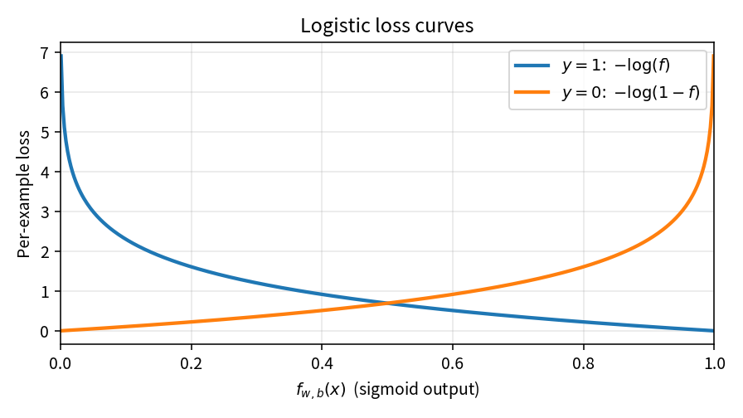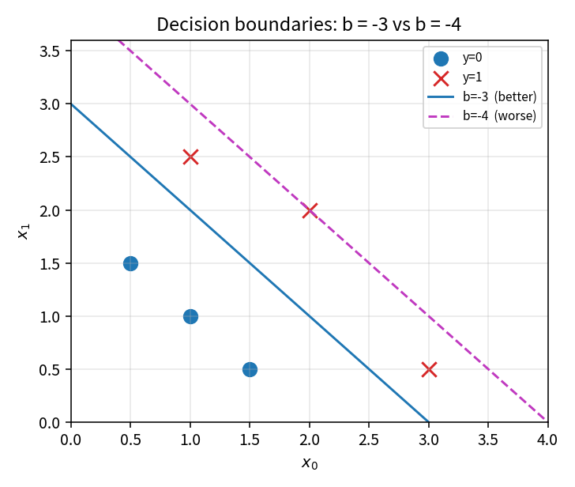
Left: the two log curves. Right: b=−3 vs b=−4 on the lab points — cheaper J matches the better cut.
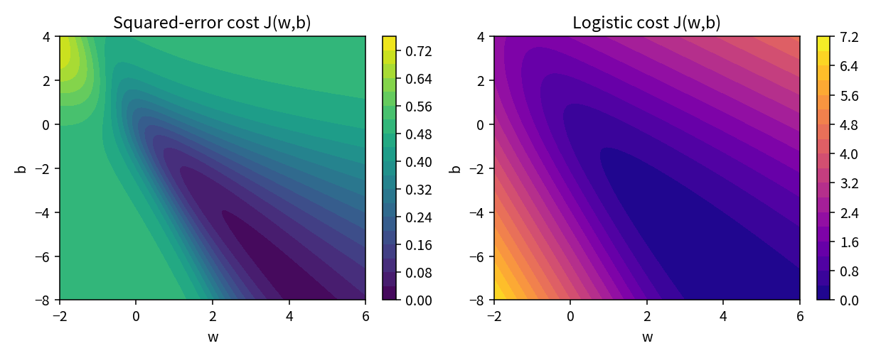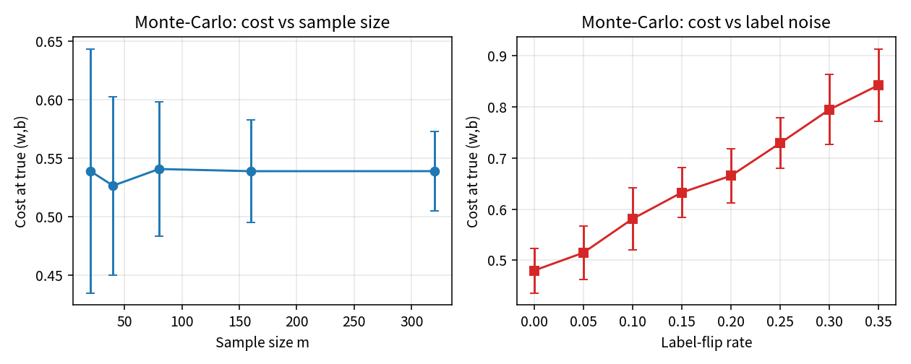
Left: squared-error surface vs logistic J(w,b). Right: J at the true parameters rises with label noise and settles as m grows.

Key Takeaways
- Do not train a sigmoid model with squared error. Use logistic / BCE loss.
- Loss is one row; cost is the mean. Lower J means the current (w,b) is more consistent with the labels.
- Clip probabilities. A single f=0 or f=1 turns log into inf and poisons the batch.
- J is convex for linear logistic regression, which is why the next lab can run gradient descent.
- Say “0.37 vs 0.50 average surprise” to an executive; keep z, g(z), and BCE for the analyst.

